|  |  |  |
| --- | --- | --- |
|  | **CENTRO DE MASA** |  |

Ecuación ejes paralelos:



**PLANTA DE CENTRO DE MASA**

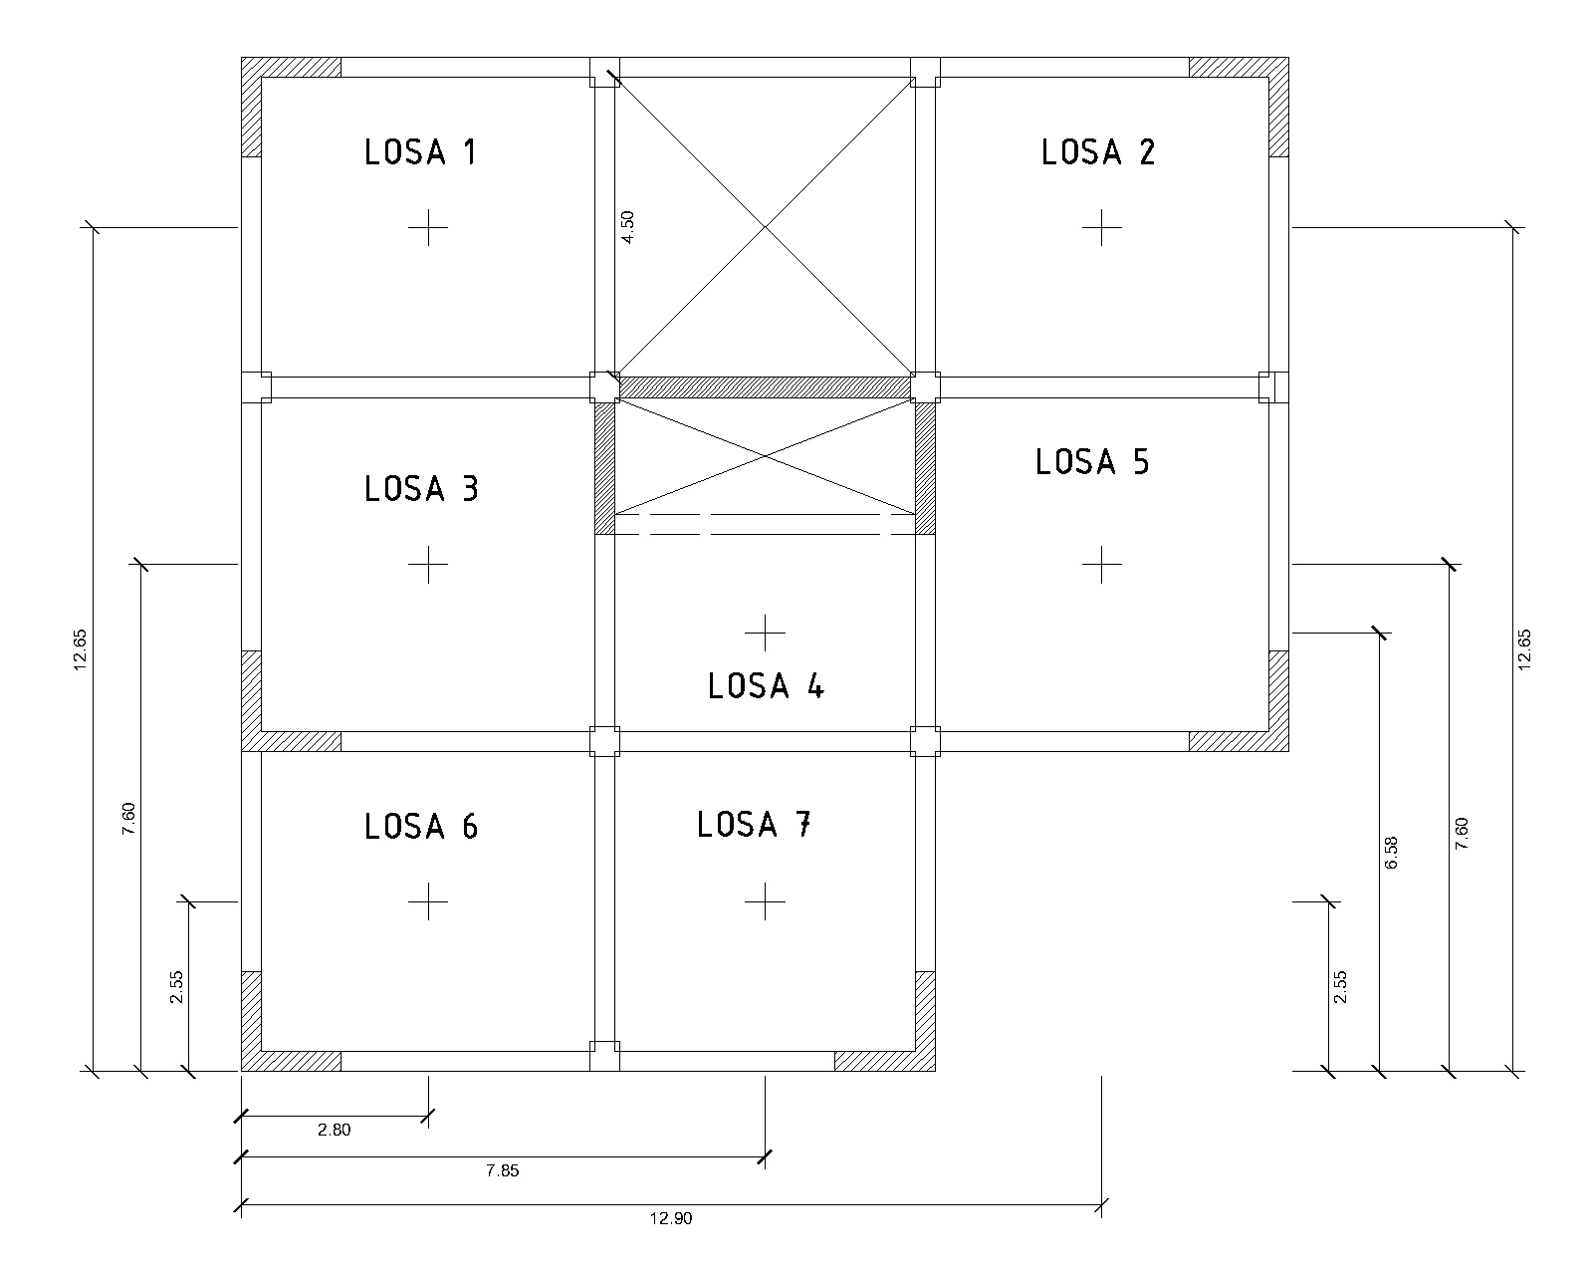

**Calculo de Centro de Masa de cada Losa**

|  |  |  |  |  |  |
| --- | --- | --- | --- | --- | --- |
| Losa | Area | X(m) | Y(m) | A*x | A*Y |
| 1 | 91.2 | 3 | 7.6 | 273.6 | 693.12 |
| 2 | 41.249 | 8.47 | 4.175 | 349.37903 | 172.214575 |
| 3 | 58.344 | 13.75 | 10 | 802.23 | 583.44 |
|  | 190.793 |  |  | 1425.20903 | 1448.774575 |

**Centro de masa de Cada edificio**

|  |  |
| --- | --- |
| **Xcm** | 7.469923058 |
| **Ycm** | 7.593436735 |

**Altura acumulada: es la suma de todos los niveles en la ruta.**

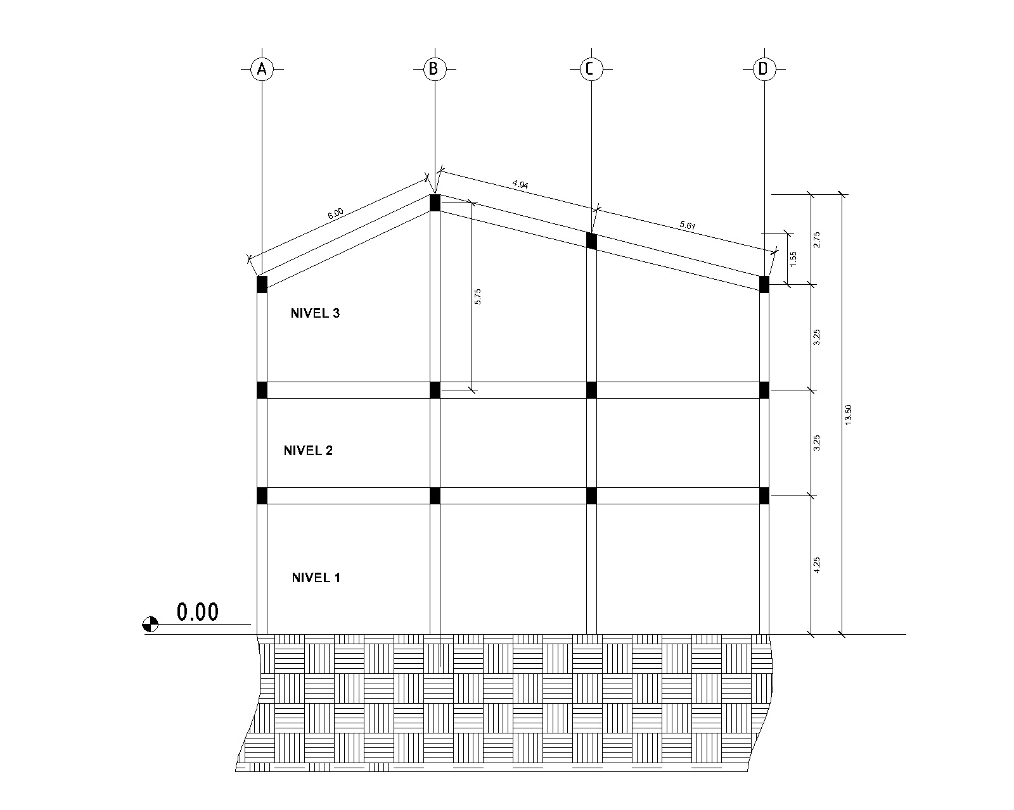

|  |  |  |
| --- | --- | --- |
| **Nivel** | **Peso Sismico (ton)** | **Altura Acumulada (m)** |
| 1 | 337.7240375 | 4.25 |
| 2 | 527.9765625 | 7.5 |
| 3 | 291.1254785 | 13.5 |
|  | 1156.826079 | 25.25 |

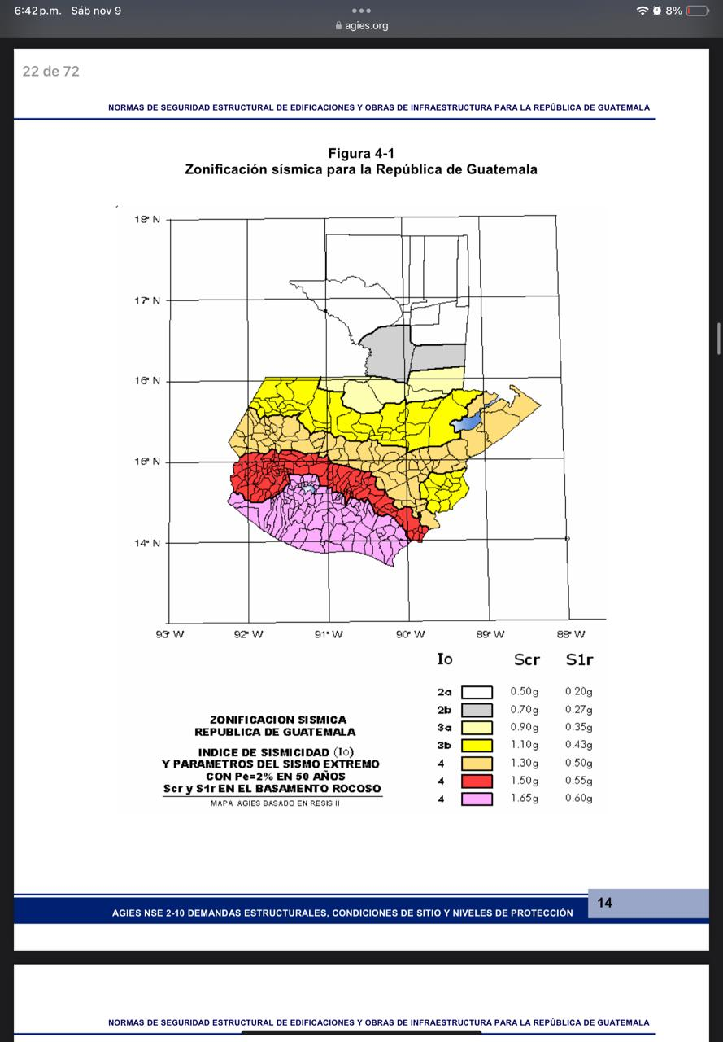

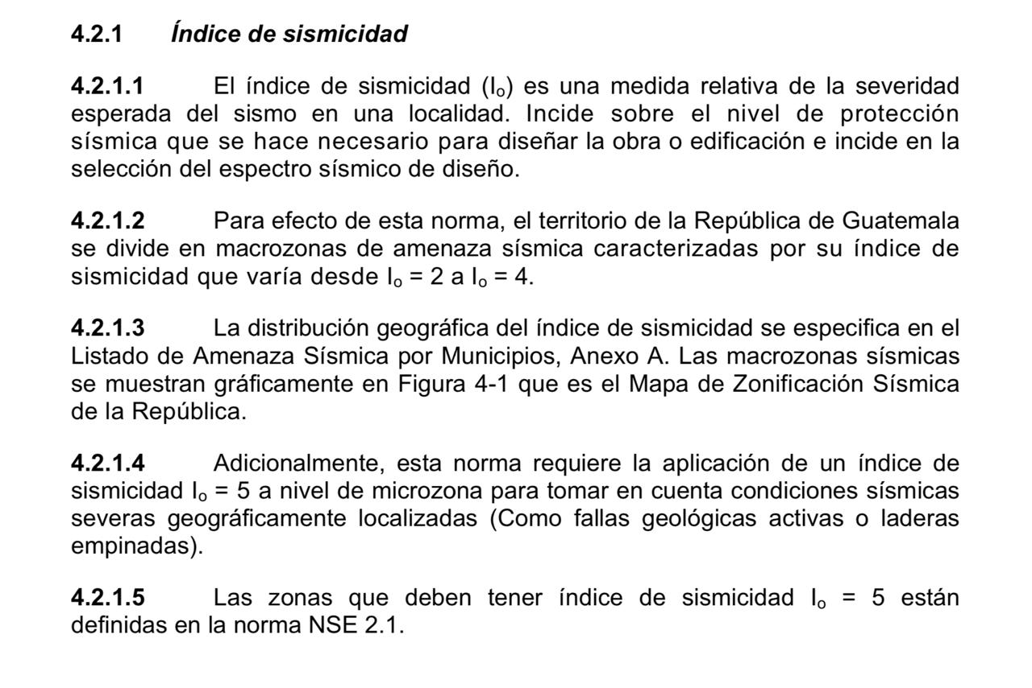

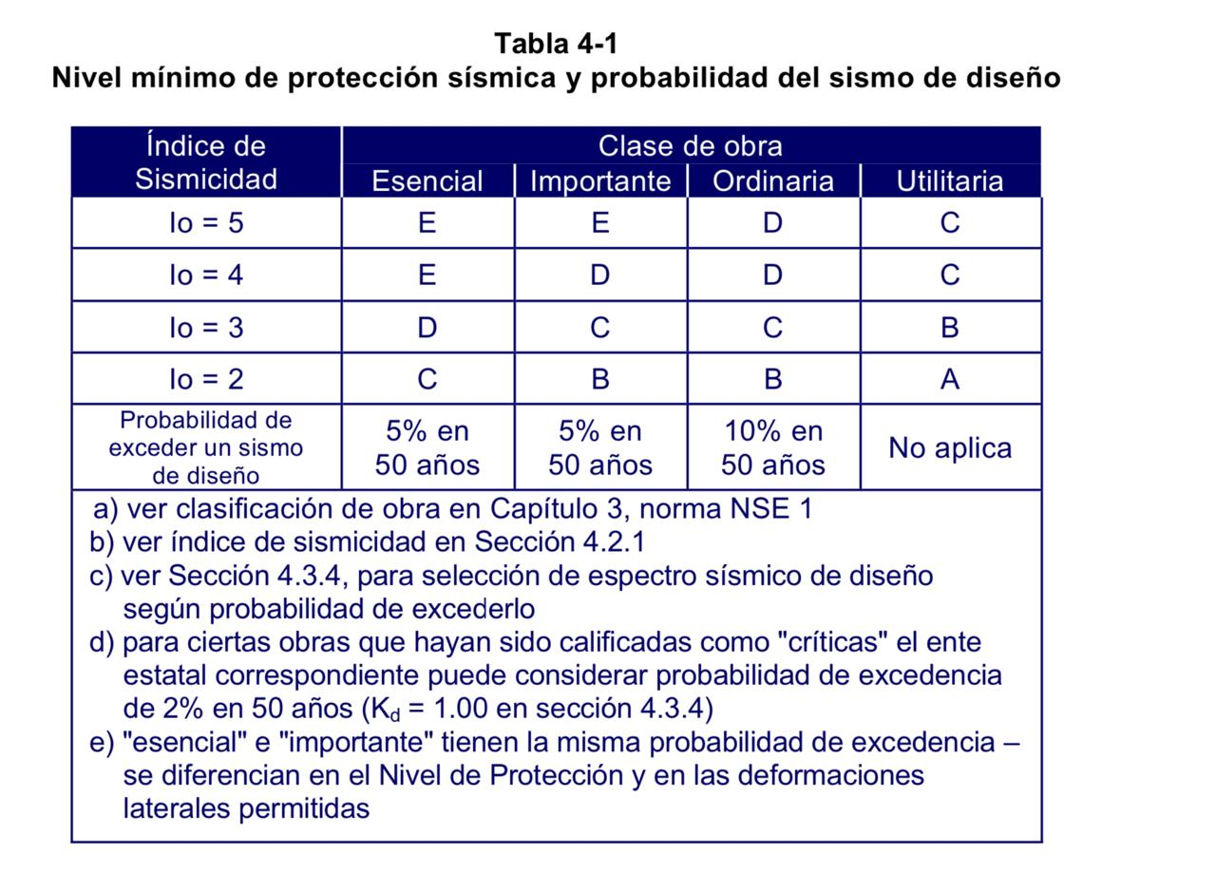

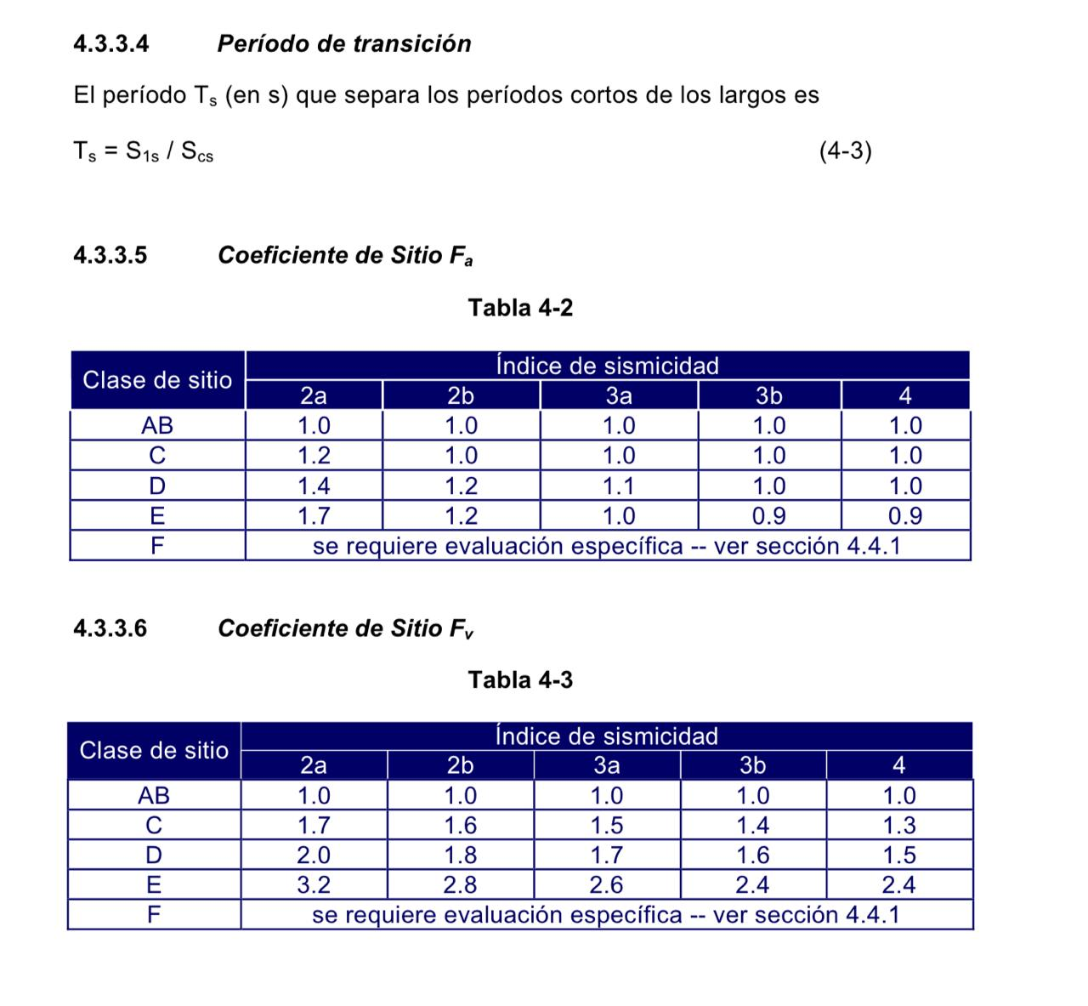

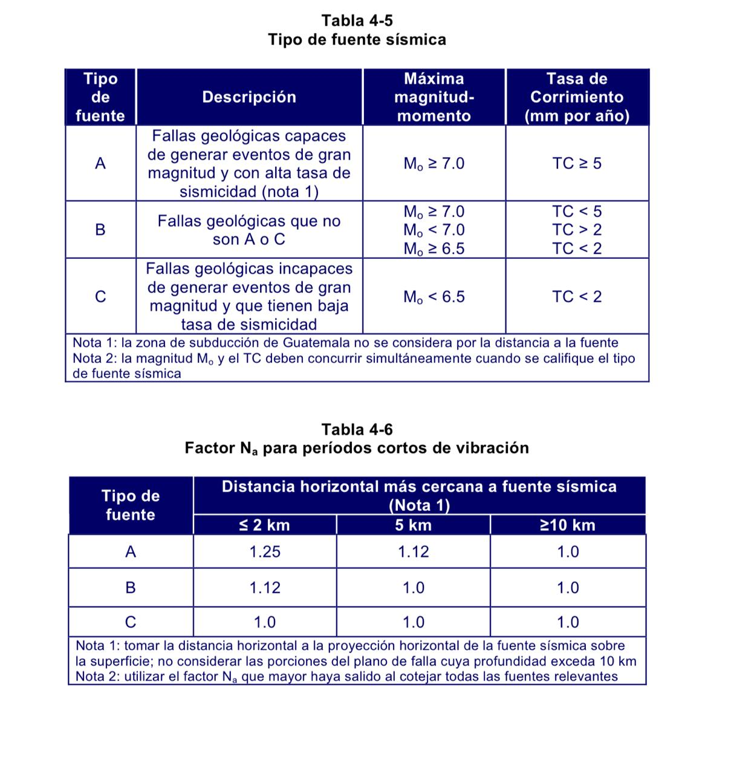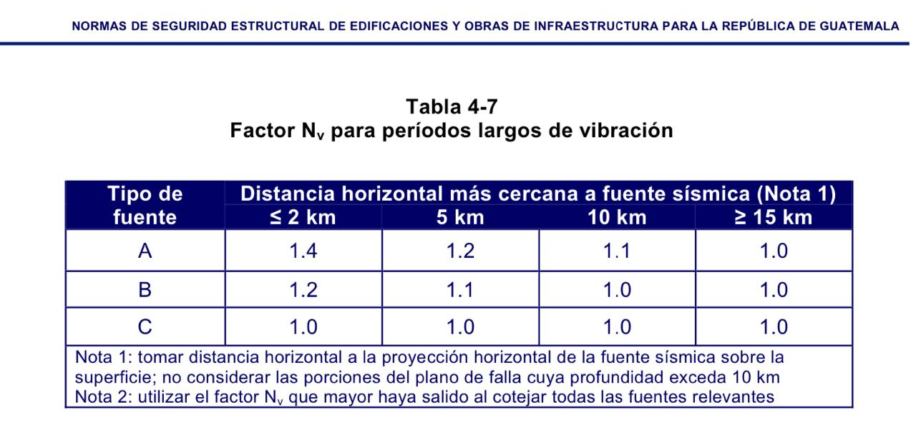

|  |  |  |  |
| --- | --- | --- | --- |
| Decripcion de Variables | Ingrese | Norma | Busqueda |
| Io= Indice de Sismicidad | 4 | NSE-2 | Figugra: 4.5-1 |
| Scr= Ordenada Espectral T corto (g) | 1.65 | NSE-2 | Figugra: 4.5-1 |
| S1r= Ordenada espectral T largo (g) | 0.6 | NSE-2 | Figugra: 4.5-1 |
| NPS = Nivel de Proteccion Sismica | D | NSE-2 | Figura: 4.2.2-1 |
| Prob = En 50 años | 5% | NSE-2 | Figura: 4.2.2-1 |
| Fa= Coeficiente de Ssitio T corto | 1 | NSE-2 | Tabla : 4.5-1 |
| Fv= Coeficientes de sitio T largo | 1.5 | NSE-2 | Tabla : 4.5-2 |
| Na = Fac. por la proximidad de amenazas | 1.12 | NSE-2 | Figura: 4.6.2-2 |
| Nv = Fac. por la proximidad de amendazas | 1.2 | NSE-2 | Figura: 4.6.2-3 |
| Kd= Factores por nivel sismico | 0.8 | NSE-2 | Figura: 4.5.5-1 |

|  |  |  |  |  |  |
| --- | --- | --- | --- | --- | --- |
| Por clase de sitio |  | |  | |  |
| Scs= Scr*Fa | 1.65 | | S1s= S1r*Fv | | 0.9 |
|  |  | |  | |  |
| Por intensidad Sismica |  | |  | |  |
| Scs= Scr*Fa*Na | 1.848 | | S1s= S1r*Fv*Nv | | 1.08 |
|  |  | |  | |  |
| Periodo de Transicion |  | |  | |  |
| Scd = Kd*Scs | 1.32 | | S1d= Kd* S1s | | 0.72 |
|  |  | |  | |  |
| Periodo de Transicion | |  | |
| Ts = S1s/Scs | | 0.545454545 | |
|  | |  | |
| Periodo deMeseta | |  | |
| To= 0.2 Ts | | 0.109090909 | |
|  | |  | |
| Aceleracion Maxima | |  | |
| AMSd= 0.40*Scd | | 0.528 | |
|  | |  | |
| Componente Vertical | |  | |
| Svd= 0.20*Scd | | 0.264 | |

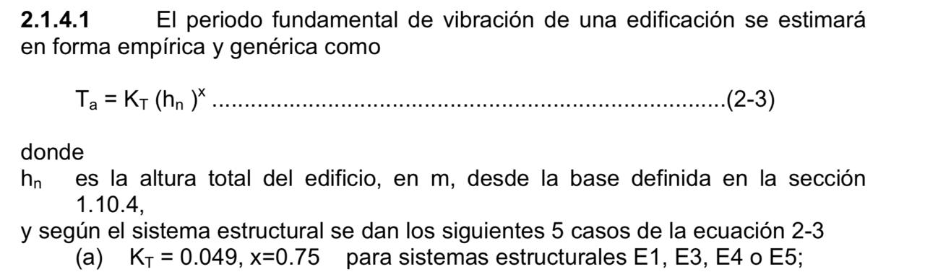

**La estructura realizada es de Tipo E 1**

|  |  |  |  |  |  |  |
| --- | --- | --- | --- | --- | --- | --- |
| T_a =K_T * ( (h_n)^ x ) |  | h_n (m) | 13.5 | Altura de Edificacion |  |  |
|  |  | K_T | 0.049 |  | Coeficiente | 2.1.6 |
| T_a | 0.34510115 | X | 0.75 |  | Coeficiente | 2.1.6 |

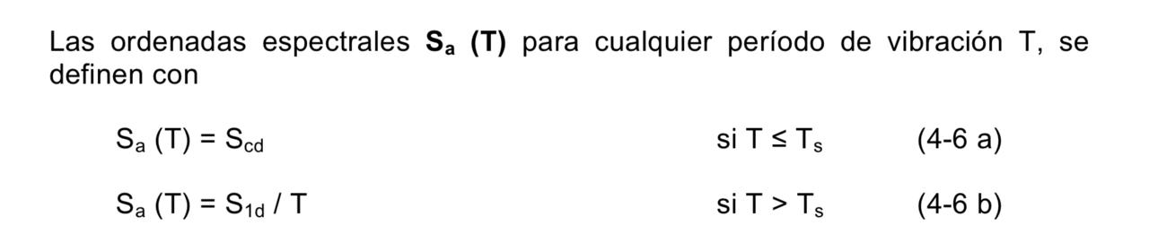

|  |  |  |  |
| --- | --- | --- | --- |
| Caso 1 | Sa(T) = Scd | Cuando To≤ T≤ Ts | 4.5.6-1 |
| Caso 2 | Sa(T) = S1d/T ≤ Scd | Cuando T > Ts | 4.5.6-2 |
| Caso 3 | Sa (T)m= Scd (0.4+0.6 T/ To) | Cuando T< To | 4.5.6-3 |

|  |  |
| --- | --- |
| To | 0.11 |
| Ta | 0.34 |
| Ts | 0.54 |

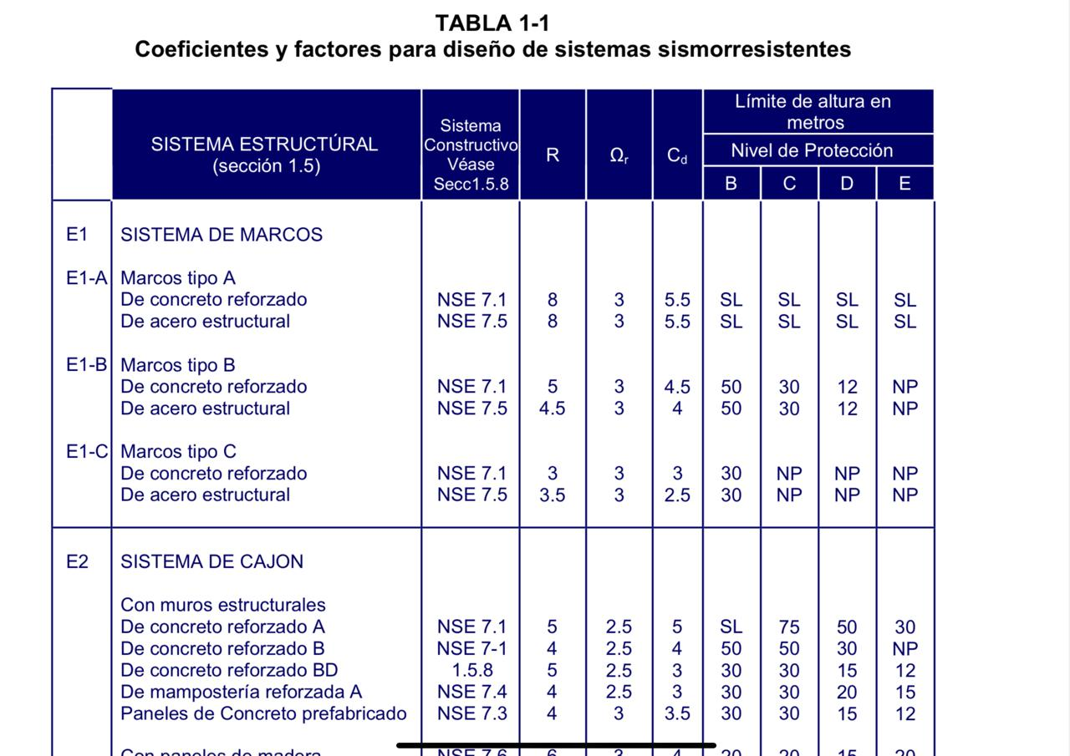

**Estructura tipo E1-A**

**De concreto reforzado**

**De acero estructural**

|  |  |  |
| --- | --- | --- |
|  | Coeficiente Sismico |  |

Sc = Sa (t)/ R

|  |  |
| --- | --- |
| Sa (T) = | 1.32 |
| R | 8 |
| Cs | 0.165 |

**Coeficiente mínimo**

|  |  |
| --- | --- |
| Cs | 0.165 |
| 0.044 Scd | 0.05808 |
| 0.75*kd *S1r/r | 0.045 |

**Periodo natural de vibración**





|  |  |
| --- | --- |
| hn (m) | 13.5 |
| Dx (m) | 15.7 |
| PNV | 0.21 |

**NOTA: El valor del PNV obtenido también servirá para determinar si a la estructura se le deberá de calcular la FUERZA TOP, pues si PNV>0.25 debe de calcularse COMO PVN ES IGUAL A 0.21 NO SE CALCULA LA FUERZA TOP**

|  |  |  |  |  |  |
| --- | --- | --- | --- | --- | --- |
| Nivel | Peso Sismico | H acumulada | Wsismico*hacum | Cx | Fp |
| 1 | 337.72 | 4.25 | 1435.327159 | 0.1539 | 28.947 |
| 2 | 527.98 | 7.5 | 3959.824219 | 0.4246 | 79.860 |
| 3 | 291.13 | 13.5 | 3930.19396 | 0.4215 | 79.263 |
|  | 1,156.83 | 25.25 | 9325.345338 | 1 | 188.070 |

|  |  |
| --- | --- |
| Vb | 190.876303 |
| F top | 2.805881653 |

|  |  |
| --- | --- |
| **Muros** |  |
| **W (kg/m2)** | 180 |
| **Espesor t(m)** | 0.3 |
| **Longitud M1 (m)** | 1.5 |
| **Longitud M2 (m)** | 1.2 |
| **Area M1 (m^2)** | 0.45 |
| **Area M2 (m^2)** | 0.36 |
| **Elevador** |  |
| **Lado Corto 1 (m)** | 1.75 |
| **Lado Corto 2 (m)** | 1.75 |
| **Lado Interno 1 (m)** | 4.35 |
| **Espesor (m)** | 0.3 |
| **Area (m^2)** | 2.355 |

|  |  |
| --- | --- |
| Rigidez por Piso |  |
|  |  |
| Ec (kg/cm2) | 282495.13 |
| Eg (kg/cm2) | 112998.05 |

|  |  |
| --- | --- |
| Elevador |  |
| Lado LARGO | 435 |
| Lado Corto 1 | 175 |
| Lado corto 2 | 175 |
| Espe t | 30 |
|  |  |

|  |  |
| --- | --- |
| Muro (cm) | |
| Long. M1 | 150 |
| Long. M2 | 150 |
| Espe t | 30 |

|  |  |
| --- | --- |
| K total en Y | 416716.6449 |

|  |  |  |  |  |  |  |  |
| --- | --- | --- | --- | --- | --- | --- | --- |
| SENTIDO Y | | | | | | | |
| Eje | ELEMENTO | NIVEL | VOLAD/EMPO | b (cm) | h (cm) | Inercia | Area (cm2) |
| A | MURO | 3 | VOLADIZO | 30 | 150 | 8437500 | 4500 |
| A | COLUMNA | 3 | VOLADIZO | 45 | 45 | 341718.75 | 2025 |
| A | MURO | 3 | VOLADIZO | 30 | 150 | 8437500 | 4500 |
| A | MURO | 3 | VOLADIZO | 30 | 150 | 8437500 | 4500 |
| B | COLUMNA | 3 | VOLADIZO | 45 | 45 | 341718.75 | 2025 |
| B | COLUMNA | 3 | VOLADIZO | 45 | 45 | 341718.75 | 2025 |
| B | EVELAVOR | 3 | VOLADIZO | 30 | 175 | 13398437.5 | 5250 |
| B | COLUMNA | 3 | VOLADIZO | 45 | 45 | 341718.75 | 2025 |
| B | COLUMNA | 3 | VOLADIZO | 45 | 45 | 341718.75 | 2025 |
| C | COLUMNA | 3 | VOLADIZO | 45 | 45 | 341718.75 | 2025 |
| C | COLUMNA | 3 | VOLADIZO | 45 | 45 | 341718.75 | 2025 |
| C | EVELADOR | 3 | VOLADIZO | 30 | 175 | 13398437.5 | 5250 |
| C | COLUMNA | 3 | VOLADIZO | 45 | 45 | 341718.75 | 2025 |
| C | MURO | 3 | VOLADIZO | 30 | 150 | 8437500 | 4500 |
| D | MURO | 3 | VOLADIZO | 30 | 150 | 8437500 | 4500 |
| D | COLUMNA | 3 | VOLADIZO | 45 | 45 | 341718.75 | 2025 |
| D | MURO | 3 | VOLADIZO | 30 | 150 | 8437500 | 4500 |

|  |  |  |  |  |  |  |  |
| --- | --- | --- | --- | --- | --- | --- | --- |
| Eje | ELEMENTO | Inercia | Area (cm2) | Altura (cm) | Ec (kg/cm2) | Ec ( kg/cm2) |  |
| A | MURO | 8437500 | 4500 | 325 | 282495.13 | 112998.05 | 5.57E-06 |
| A | COLUMNA | 341718.75 | 2025 | 325 | 282495.13 | 112998.05 | 1.20E-04 |
| A | MURO | 8437500 | 4500 | 325 | 282495.13 | 112998.05 | 5.57E-06 |
| A | MURO | 8437500 | 4500 | 325 | 282495.13 | 112998.05 | 5.57E-06 |
| B | COLUMNA | 341718.75 | 2025 | 600 | 282495.13 | 112998.05 | 7.49E-04 |
| B | COLUMNA | 341718.75 | 2025 | 600 | 282495.13 | 112998.05 | 7.49E-04 |
| B | EVELAVOR | 13398437.5 | 5250 | 600 | 282495.13 | 112998.05 | 2.02E-05 |
| B | COLUMNA | 341718.75 | 2025 | 600 | 282495.13 | 112998.05 | 7.49E-04 |
| B | COLUMNA | 341718.75 | 2025 | 600 | 282495.13 | 112998.05 | 7.49E-04 |
| C | COLUMNA | 341718.75 | 2025 | 460 | 282495.13 | 112998.05 | 3.39E-04 |
| C | COLUMNA | 341718.75 | 2025 | 460 | 282495.13 | 112998.05 | 3.39E-04 |
| C | EVELADOR | 13398437.5 | 5250 | 460 | 282495.13 | 112998.05 | 9.50E-06 |
| C | COLUMNA | 341718.75 | 2025 | 460 | 282495.13 | 112998.05 | 3.39E-04 |
| C | MURO | 8437500 | 4500 | 460 | 282495.13 | 112998.05 | 1.47E-05 |
| D | MURO | 8437500 | 4500 | 325 | 282495.13 | 112998.05 | 5.57E-06 |
| D | COLUMNA | 341718.75 | 2025 | 325 | 282495.13 | 112998.05 | 1.20E-04 |
| D | MURO | 8437500 | 4500 | 325 | 282495.13 | 112998.05 | 5.57E-06 |

|  |  |  |  |
| --- | --- | --- | --- |
| Eje | ELEMENTO | Rigidez K | K total de eje |
| A | MURO | 179,608.36 |  |
| A | COLUMNA | 8,316.70 |  |
| A | MURO | 179,608.36 | 547,141.79 |
| A | MURO | 179,608.36 |  |
| B | COLUMNA | 1,335.12 |  |
| B | COLUMNA | 1,335.12 |  |
| B | EVELAVOR | 49,416.48 | 54,756.94 |
| B | COLUMNA | 1,335.12 |  |
| B | COLUMNA | 1,335.12 |  |
| C | COLUMNA | 2,954.08 |  |
| C | COLUMNA | 2,954.08 |  |
| C | EVELADOR | 105,234.56 | 182,134.46 |
| C | COLUMNA | 2,954.08 |  |
| C | MURO | 68,037.68 |  |
| D | MURO | 179,608.36 |  |
| D | COLUMNA | 8,316.70 | 367,533.42 |
| D | MURO | 179,608.36 |  |
| K total Y | | 1,151,566.61 |  |

|  |  |  |  |
| --- | --- | --- | --- |
| TOMA EN X |  |  |  |
| Eje | Dy | K | K*Dy |
| A | 0.15 | 5,471.42 | 820.71 |
| B | 5.45 | 547.57 | 2,984.25 |
| C | 10.25 | 1,821.34 | 18,668.78 |
| D | 15.55 | 3,675.33 | 57,151.45 |
| TOTAL | 31.4 | 11,515.67 | 79,625.20 |

|  |  |  |  |
| --- | --- | --- | --- |
| Eje | Dx | K | K*Dx |
| 1 | 15.05 | 3,635.06 | 54,707.64 |
| 2 | 10.25 | 21,886.50 | 224,336.62 |
| 3 | 4.95 | 3,635.06 | 17,993.54 |
| 4 | 0.15 | 2,489.81 | 373.47 |
| TOTAL | 30.4 | 31,646.43 | 297,411.28 |

|  |  |
| --- | --- |
| Ecuacion de Ejes paralelos | |
| Hallamos Centro de Rigideces | |
|  |  |
| Xcr | 7.84 |
| Ycr | 6.91 |
|  |  |
| Xcm | 7.47 |
| Ycm | 7.59 |

|  |  |
| --- | --- |
| e Exentricidad |  |
| ex (m) | 0.37 |
| ey(m) | 0.68 |

|  |  |
| --- | --- |
| Distribucion de Fuerzas por Eje |  |

|  |  |  |  |
| --- | --- | --- | --- |
|  | Fuerza de Piso |  |  |
| Nivel | Peso Sismico | h Acumulada | Fp (ton) |
| 1 | 337.7240375 | 4.25 | 28.947 |
| 2 | 527.9765625 | 7.5 | 79.860 |
| 3 | 291.1254785 | 13.5 | 79.263 |
| 3 | 1156.826079 | 25.25 | 188.070 |

**CARNET PAR –FUERZA EN X-X..**

|  |  |  |  |  |
| --- | --- | --- | --- | --- |
|  | Fuerza Por eje |  |  |  |
| Eje | Nivel | K | Fp (ton) | Feje (ton) |
| 1 | 3 | 3,635.06 | 79.26 | 9.104 |
| 2 | 3 | 21,886.50 | 79.26 | 54.816 |
| 3 | 3 | 3,635.06 | 79.26 | 9.104 |
| 4 | 3 | 2,489.81 | 79.26 | 6.236 |
|  |  | 31,646.43 |  |  |

